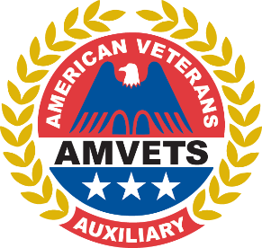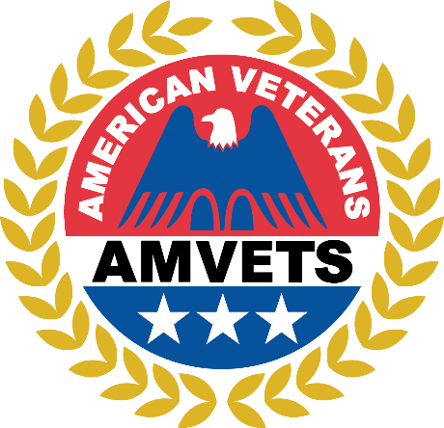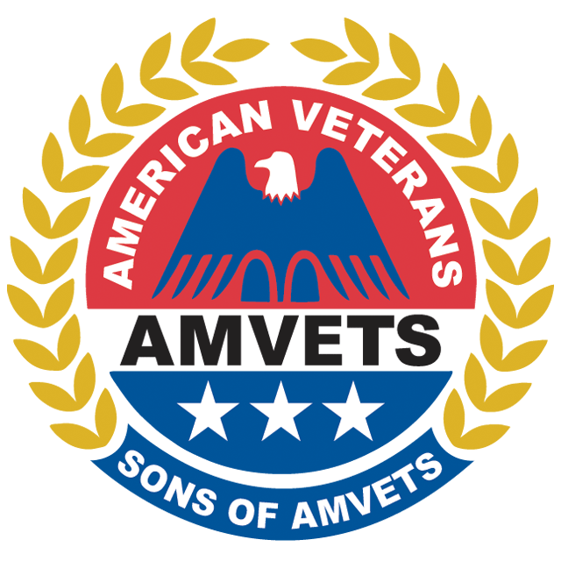

You are cordially invited to join us for the AMVETS Department of Ohio Joint Testimonial Dinner

This event will be held Saturday February 24th, 2024, at 6:30 PM at the Mariott Northwest Hotel

Dinner is $30.00 per guest

All AMVETS, Auxiliary, Sons, and guests are welcome to celebrate our Commanders and President

Attire for the evening is business casual

We look forward to seeing you, please RSVP with the attached form
2024 TESTIMONIAL DINNER RESERVATION FORM

MENU
Maple Mustard Glazed Spice Crusted Pork Loin, Smoked Cheddar Mashed Potatoes, Ceasar Salad, Country Green Beans, Flourless Chocolate Torte, Coffee

Name
Post #
Phone

Number of Attendees At $30.00 per attendee total sum paid $

Pay By Credit Card

Name on Card Post # Credit Card # Exp _ / _ Billing Address for Card CVC
City State Zip
Email Address

Pay by Check

I have enclosed check # in the amount of $

Names of Dinner Attendees:

Make checks payable to AMVETS Department of Ohio and send to: 960 Checkrein Avenue, Columbus OH 43229

Reservations must be postmarked no later than February 15, 2024

You may also visit www.ohamvets.org to RSVP online

