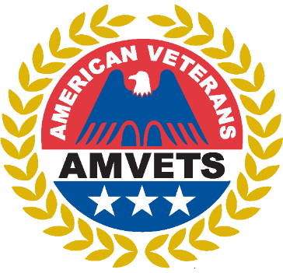 37 ^{th} Annual
Legislative Breakfast

SATURDAY, FEBRUARY 24, 2024, AT 8:30 AM
~
Honor the Ohio Legislators who worked on behalf of Veterans of Ohio.
~
The Breakfast will be at the Mariott Northwest Hotel
Scrambled Eggs, Biscuit with Sausage Gravy, Breakfast Potatoes, Bacon and Served with Orange Juice, Coffee & Tea

All AMVETS, Subsidiaries and Guests are welcome to attend.

Business Attire
2024 LEGISLATIVE BREAKFAST RESERVATION FORM

Register and purchase tickets online at www.ohamvets.org and click “Shop.” Register your delegates and officers, as well as purchase tickets for the Legislative Breakfast.

Name ____________________________ Post # __________ Phone ___________________________

Number of Attendees __________ At $20.00 per attendee total sum paid $__________

Pay By Credit Card

Name on Card _______________________________________________ Post # _________
Credit Card # ________________________________________________ Exp ____ / _____
Billing Address for Card ____________________________________ CVC ___________
City __________________________________ State ____________ Zip ____________
Email Address __________________________________________________________________

Pay by Check

I have enclosed check # ______________ in the amount of $ _______________

Names of Breakfast Attendees:

_________________________________________ ___________________________________________

_________________________________________ ____________________________________________

Be sure to include the names of the breakfast attendees.
Make checks payable to AMVETS Department of Ohio and send to:
960 Checkrein Avenue, Columbus OH 43229

Reservations must be postmarked no later than February 15, 2024
You may also visit www.ohamvets.org to RSVP online

