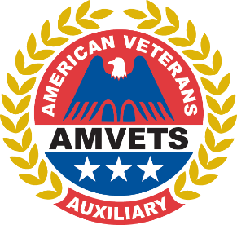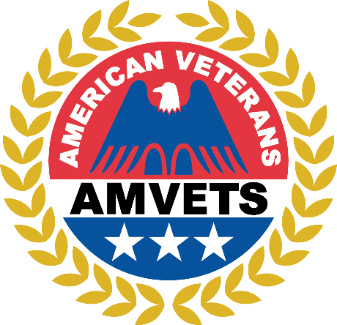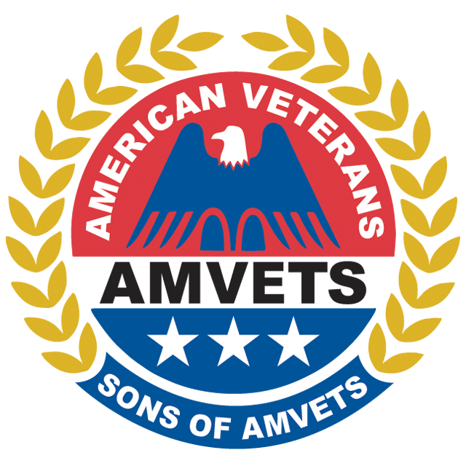

You are cordially invited to join us for the AMVETS Department of Ohio Joint Testimonial Dinner

This event will be held Saturday February 21st, 2026, at 6:30 PM at the Marriott Northwest Hotel

Dinner is $35.00 per guest

All AMVETS, Auxiliary, Sons, and guests are welcome to celebrate our Commanders and President

Attire for the evening is business casual

We look forward to seeing you, please RSVP with the attached form
2026 TESTIMONIAL DINNER RESERVATION FORM

MENU
Center Cut Filet Mignon, Smoked Cheddar Mashed Potatoes, Salad, Green Beans
and Flourless Chocolate Torte

Name
Post #
Phone

Number of Attendees At $35.00 per attendee total sum paid $

Pay By Credit Card

Name on Card Post # Credit Card # Exp _ / _ Billing Address for Card CVC
City State Zip
Email Address

Pay by Check

I have enclosed check # in the amount of $

Names of Dinner Attendees:

Make checks payable to AMVETS Department of Ohio and send to: 960 Checkrein Avenue, Columbus OH 43229

Reservations must be postmarked no later than February 13, 2026

You may also visit www.ohamvets.org to RSVP online

